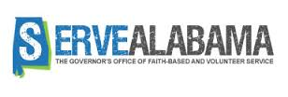

Alabama AmeriCorps State

Funding Opportunity

Priority Area: Reducing and/or Preventing Prescription Drug and Opioid Abuse

TIMELINE
March 15, 2017: Letter of Intent due (See template)
April 7, 2017: Application Due in E-grants and Additional Documents received by Serve Alabama by 4:00pm CST
April 8 – May 1, 2017: Review and Clarification period
May 4, 2017: State Service Commission Meeting
May 10, 2017: Deadline for Serve Alabama to submit application to CNCS
July 11, 2017: Applicants notified no later than this date (subject to change)

ADDITIONAL DOCUMENTS NEW APPLICANTS ONLY
- NEW ONLY Financial Management Survey (WORD DOC)
- Program Diagram (WORD DOC)
- Copy of Most Recent Audit

E-GRANTS
Grant Application ID: 17AC192734
NOFA: FY 2017 AmeriCorps State and Territory Commission (New and Continuations)
Type: New
Status: Open for Subapplications

